**Calc AB 3 Lesson Plan:**

Slides:

<https://docs.google.com/presentation/d/1ZoMJP2-NFcLftlGBONDpLu0d7OP6VezaDrt3R6AwdqA/edit?usp=sharing>

Goals for Three Day Lesson Plan For Calc AB regarding Climate and Sustainability:

* Inform the class about the application of calculus through the basics of climate change, e.g. The extremity of the issue at hand and how action is needed ASAP
* Provide the class with data, graphs, and information that can be analyzed in a mathematical manner.
* Students take away the true impact of CO2 emissions and global warming, hopefully invoking a sense of urgency towards climate issues.
* Students understand how mathematics is extremely useful towards saving our planet!

**Day 1: Introduction to Climate Change and Carbon Footprint**

* Objective: Introduce students to climate change data and develop their skills in analyzing and interpreting data through real-life graphs.
* Activities:
  + Start the class with a brief introduction of climate change: its causes, factors, etc.
  + Introduce CO2 emissions, carbon footprint definition
  + Make students calculate their overall footprint using [Ecological Footprint Calculator](https://www.footprintcalculator.org/home)
    - View more data regarding your answers
    - View the graphs about different ecological footprints across the globe
      * What trend are the graphs on?
      * What events could have caused sharp increases or dips in the graph?
  + Using a variety of calculations, your footprint is measured. Connect to calculus how we can predict future data points with only current data. (Limits)

**Day 2: Modeling Climate Change Scenarios**

* Objective: Apply mathematical modeling skills to predict future climate change scenarios.
* Activities:
  + Review mathematical modeling trends such using concavity (concave up and down) and use what you learn to apply to current data sets of CO2 emissions and pollutants. **Think:** is it increasing/ decreasing at a quick rate or maybe slower (logarithmic function)
  + Provide students with historical data sets and guide them in developing mathematical models
  + Support students in analyzing and interpreting those same models, including making predictions and drawing conclusions + use limits to predict future numbers

**Day 3: More Calculus Applications**

* Objective: Use the concept of integration to evaluate climate data
* -For this graph below, we can take the growth rate, or the velocity of the GDP and find the area under the curve to calculate the total growth rate over a certain amount of time. 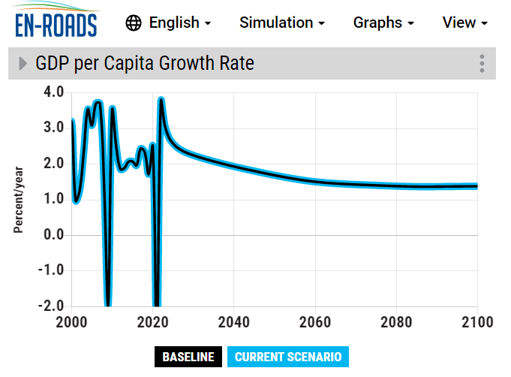For this, we could use a Riemann sum to estimate the area under the curve.

**Short Summary:**

In this three-day lesson plan for Calculus AB on climate and sustainability, the main goals are to inform students about the application of calculus in understanding climate change and provide them with data and graphs for mathematical analysis.

Day 1 focuses on introducing climate change and carbon footprint. Students learn about the causes and factors of climate change, calculate their own carbon footprint using an Ecological Footprint Calculator, and analyze graphs on ecological footprints globally

Day 2 revolves around modeling climate change scenarios. Students explore steps governments can take to decrease carbon emissions, review mathematical modeling techniques, examine cases of countries successfully reducing their footprint, and develop their own mathematical models to predict future climate change trends.

Day 3 delves into using the concept of integration to evaluate climate data. Students evaluate a graph that plots data on the growth rate of the GDP of the world after certain climate legislation is passed. Finding and estimating the area under the curve using a Riemann Sum will find the total GDP over a certain amount of time. Skills like this can be applied to various data sets regarding climate and sustainability.

Throughout the lesson plan, students enhance their skills in analyzing and interpreting data, applying mathematical models, and critically evaluating sustainability solutions. The aim is to instill a deeper understanding of the impact of CO2 emissions and global warming while emphasizing the role of mathematics in addressing climate challenges.